## **A Mini - Project Report**

**on**

## **“Face Recognition and Smile Detection”**

Submitted to the

Pune Institute of Computer Technology, Pune In partial fulfillment for the award of the Degree of Bachelor of Engineering

in

#### Information Technology

by

**Neelanjney Pilarisetty 43237**

**Pallavi Dadape 43239**

**Hrishikesh Pawar 43244**

Under the guidance of

## **Prof. R. R. Chhajed**

#### Department Of Information Technology

Pune Institute of Computer Technology College of Engineering

Sr. No 27, Pune-Satara Road, Dhankawadi, Pune - 411 043.

**2020-2021**

**I**

## **CERTIFICATE**

This is to certify that the project report entitled

**Face recognition & Smile Detection**

Submitted by

Neelanjney Pilarisetty 43237

Pallavi Dadape 43239

Hrishikesh Pawar 43244

is a bonafide work carried out by them under the supervision of Prof. R. R.Chhajed and it is approved for the partial fulfillment of the requirement of **Computer Laboratory-X** for the award of the Degree of Bachelor of Engineering (Information Technology)

| **Prof. R. R. Chhajed** | **Dr. A. M. Bagade** |
| --- | --- |
| Lab Teacher | Head of Department |
| Department of Information Technology | Department of Information Technology |
|  |  |
| Place: |  |
| Date: |  |

**II**

## **ACKNOWLEDGEMENT**

We thank everyone who has helped and provided valuable suggestions for successfully creating a wonderful project.

We are very grateful to our guide, Prof. R. R. Chhajed, Head of Department, Dr. A. M. Bagade and our principal Dr. R. Sreemathy. They have been very supportive and have ensured that all facilities remain available for smooth progress of the project.

We would like to thank our professor and Prof. R. R. Chhajed for providing very valuable and timely suggestions and help.

Neelanjney Pilarisetty

Pallavi Dadape

Hrishikesh Pawar

**III**

## **ABSTRACT**

Over the last few years, the processing capacity of mobile phones has continuously increased, and has now reached a point where some mobile phones can run large programmes with relative success. Over the same time span, applications with facial detention and recognition capabilities have progressed to the point that successful facial recognition may be performed with far less processing power.

Face recognition applications can now be run on mobile phones because of these advancements. Mobile phones perform facial recognition, which is the technique of identifying specific people in a digital image by recognising traits. Due to the extremely great quality of the smartphone's camera, we can capture high-resolution pictures and perform many forms of recognition on them. In today's world, face recognition is fairly common. Every day, we use it through social media sites, video games, and in security to restrict access to private areas to authorized individuals. These are just a few examples of how facial recognition can be used, because in today's culture, detection and facial recognition are all around us. The goal of this project is to develop a smartphone application that can recognise human faces by capturing their smiling faces.

**IV**

## **LIST OF FIGURES**

| **Sr. No.** | **Title** | **Page No.** |
| --- | --- | --- |
| 1 | System overview | 12 |
| 2 | ML architecture | 12 |
| 3 | Data flow diagram | 13 |

**V**

## **LIST OF TABLES**

| **Sr. No.** | **Title** | **Page No.** |
| --- | --- | --- |
| 1 | Implementation Steps | 13 |
| 2 | Difference between bundled and unbundled models | 14 |

**LIST OF TOPICS**

1. OVERVIEW
2. INTRODUCTION
3. SCOPE AND OBJECTIVE
4. SYSTEM ARCHITECTURE
5. ML KIT On ANDROID
6. CODES AND SNAPSHOT
7. CONCLUSION AND FUTURE SCOPE
8. REFERENCES

**OVERVIEW**

The demands for recognizing humans have grown in almost every industry, majorly security. As a result, we propose using active learning techniques to accelerate the training process. The goal of this project is to design a lightweight and accurate application for smartphones that can recognize humans. Through testing and comparing different learning algorithms, we find one that best fits our system in terms of efficiency and accuracy on a smartphone. Human Face and Smile Recognition is a multidisciplinary research field that aims to gather data regarding people's faces and their smiles at various instances in order to deliver valuable context-aware information. It has nowadays contributed to develop human centered areas of study such as Ambient Intelligence and Ambient Assisted Living, which concentrate on the improvement of people's Quality of Life.

**INTRODUCTION**

The field of face detection and recognition has attracted a lot of attention in recent times, this can be attributed to the large range of applications that it could be used for varying from access control, surveillance and security, personnel profiling and biometrics. But even though a considerable amount of man hours as well as resources have already been devoted to the field, it is still a very attractive field to venture into since most of the work done are computer based application while this project would be implement on a mobile phone which has much resource available to it as compared to conventional computers.

Face and Smile Recognition system takes the raw sensor readings from mobile sensors. Due to its unassertive, non-/low installation cost and easy-to-use, smartphones are becoming the main platform for human activity recognition. In our approach; we focus on robust face recognition using either an in-built camera or any image capturing application on smartphones.  
  
This project presentes the face and smile recognition system based on smartphones. The face vision model is implemented on Android phones to detect smiles on faces and gives the percentage of the smile detected.

\

**SCOPE**

This project wishes to design an end to end Android application supported by Face Vision Model. It involves the creation of a mobile android application which implements face detection as well as recognition. The project begins with the development of a background application on android’s development platform (android studio). The application would include foreground android features such as Layout, text-views, image-view, surface-view as well as buttons. This is written in xml to represent the GUI (Graphic User Interface) which is what the user of the application sees and can communicate with. With the completion of the background and foreground, one can move on to the development of functions which are implemented in the java class file of the android project. The java class file would also contain the codes that perform various tasks that are displayed to the user via the GUI.

**OBJECTIVE**

The aim of this project is to develop an android mobile application with the following

capabilities.

- Face detection

- Face recognition

- Smile detection

The world we live in today is much different from that of just a decade ago, one change that is much more profoundly noticeable is the need in the healthcare domain and for security. For this rapid evolution, a modern approach is the necessity. A mobile phone would be loaded with a facial detection and recognition application that is capable of detecting smiling faces.

**SYSTEM ARCHITECTURE**

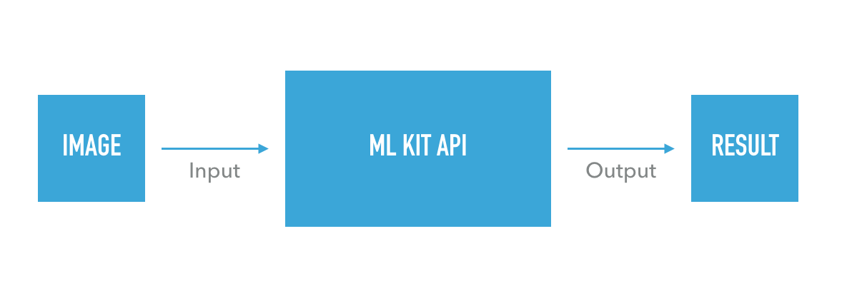

**Fig1: System overview**

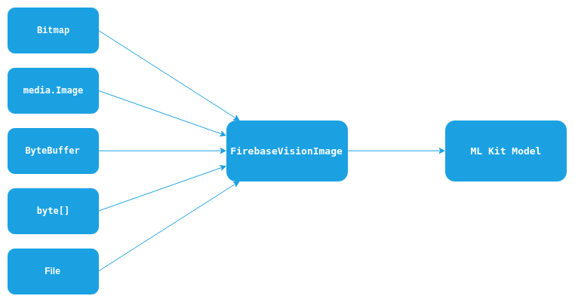

**Fig2: ML architecture**

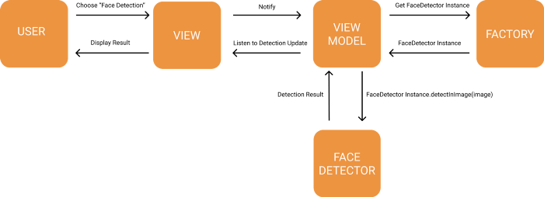

**Fig3: Data Flow Diagram**

**FIREBASE**

With ML Kit's face detection API, we can detect faces in an image, identify key facial features, and get the contours of detected faces.

With face detection, you can get the information you need to perform tasks like embellishing selfies and portraits, or generating avatars from a user's photo. Because ML Kit can perform face detection in real time, you can use it in applications like video chat or games that respond to the player's expressions.

| **IMPLEMENTATION** | | |
| --- | --- | --- |
| **STEP 1** | **STEP 2** | **STEP 3** |
| Integrating the SDK | Preparing input data | Appling the ML model to your data |
| Quickly include the SDK using Gradle | For example, if you're using a vision feature, capture an image from the camera and generate the necessary metadata such as image rotation, or prompt the user to select a photo from their gallery. | By applying the ML model to your data, you generate insights such as the emotional state of detected faces or the objects and concepts that were recognized in the image, depending on the feature you used. Use these insights to power features in your app like photo embellishment, automatic metadata generation, or whatever else you can imagine. |

**Table1: Implementation steps**

**ML KIT On ANDROID**

ML Kit on Android is used to detect faces from images and videos. There are two ways to incorporate face detection:

1. Bundled model which is an element of the application
2. Unbundled model of the application

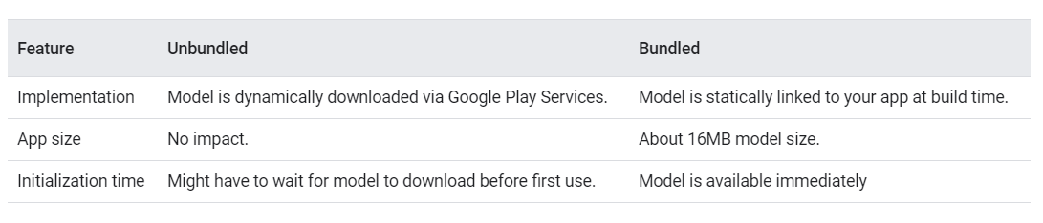

**Table 2: Difference between Bundled and Unbundled model**

**Input Image Guidelines**

* For face recognition, the dimension of the picture should be at least 480 x 360 pixels. For ML Kit to accurately detect faces, input images must contain faces that are represented by sufficient pixel data. In general, each face to be detected should be a minimum of 100x100 pixels.
* Poor image focus impacts accuracy directly. Another major factor affecting the detection output is the orientation of the camera relative to the face. If the image is not captured correctly, the facial features and expression will not be detected rightly.

**CODES**

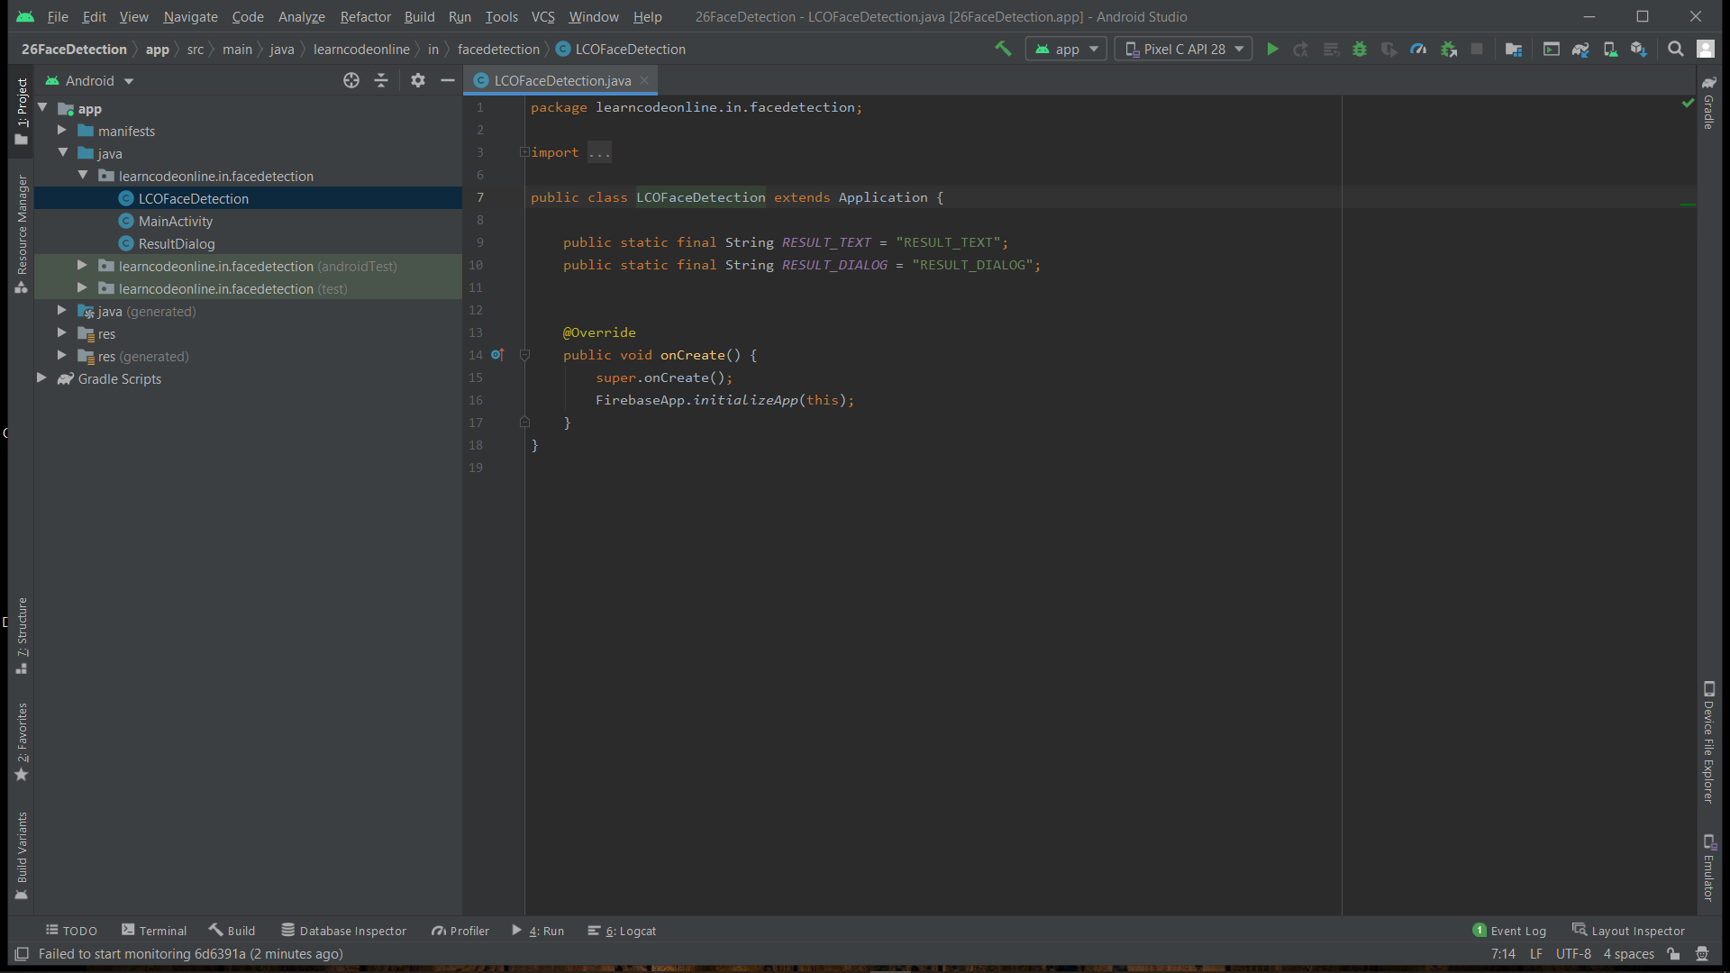

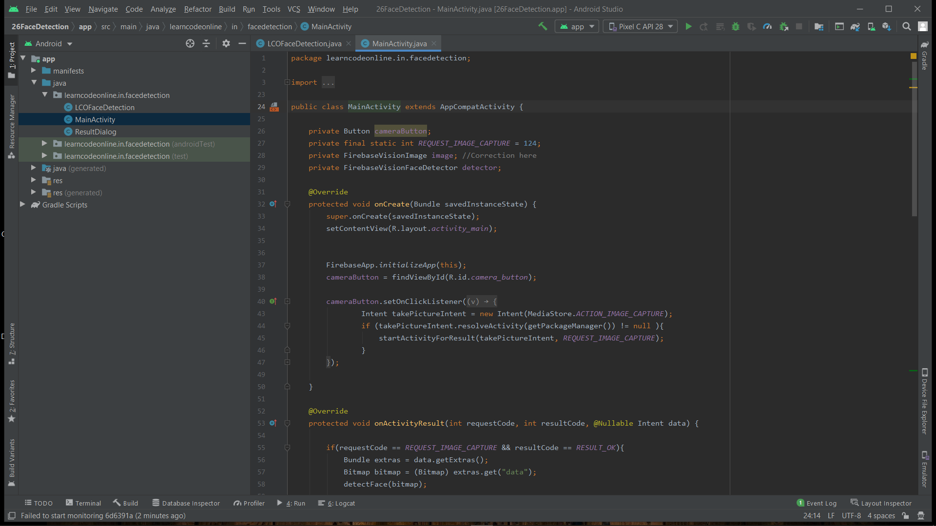

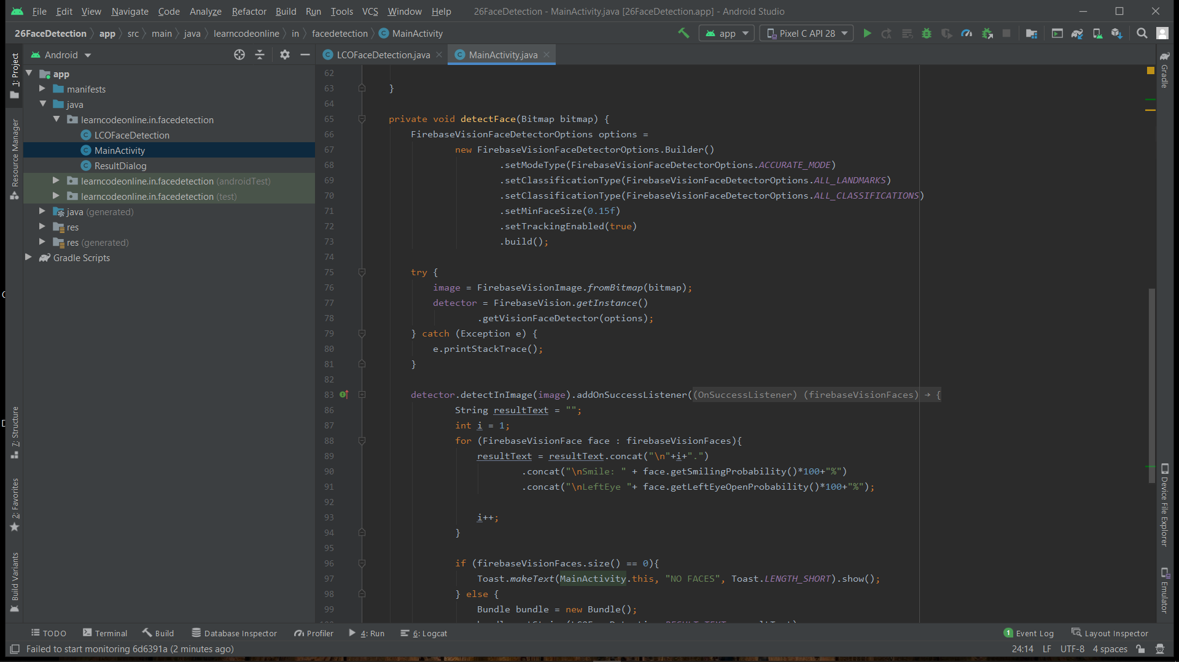

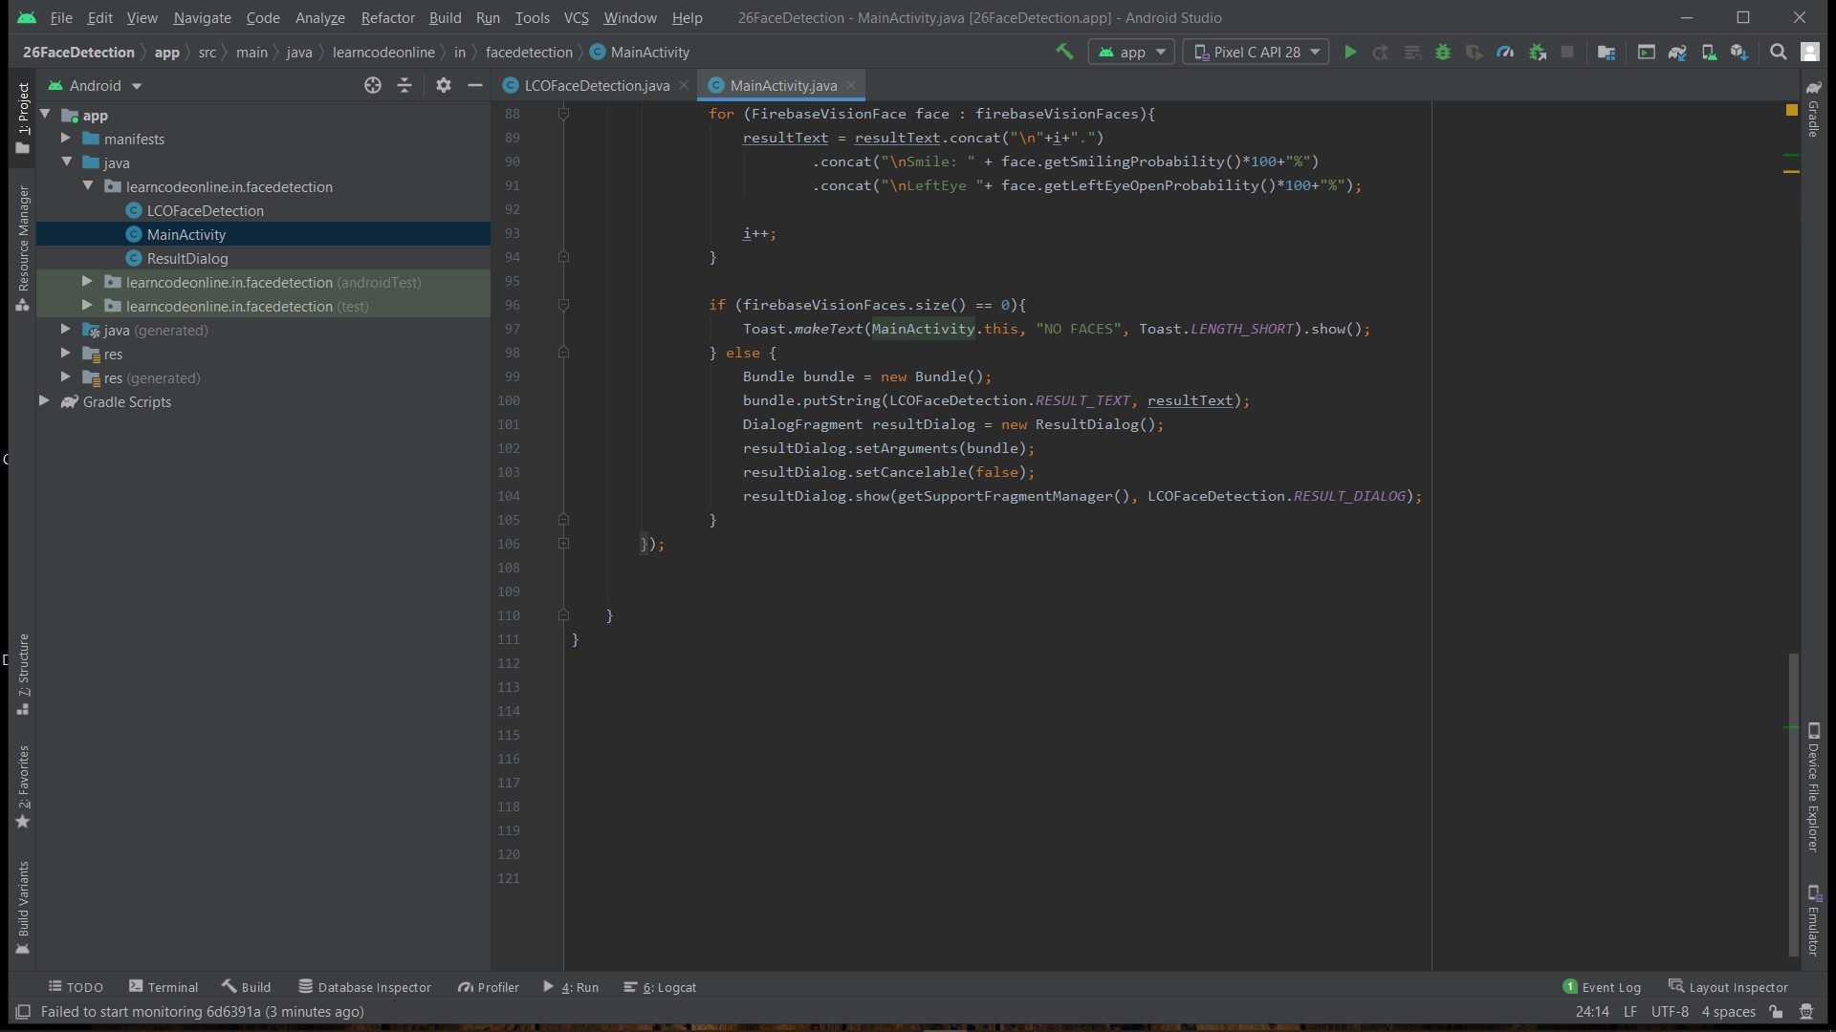

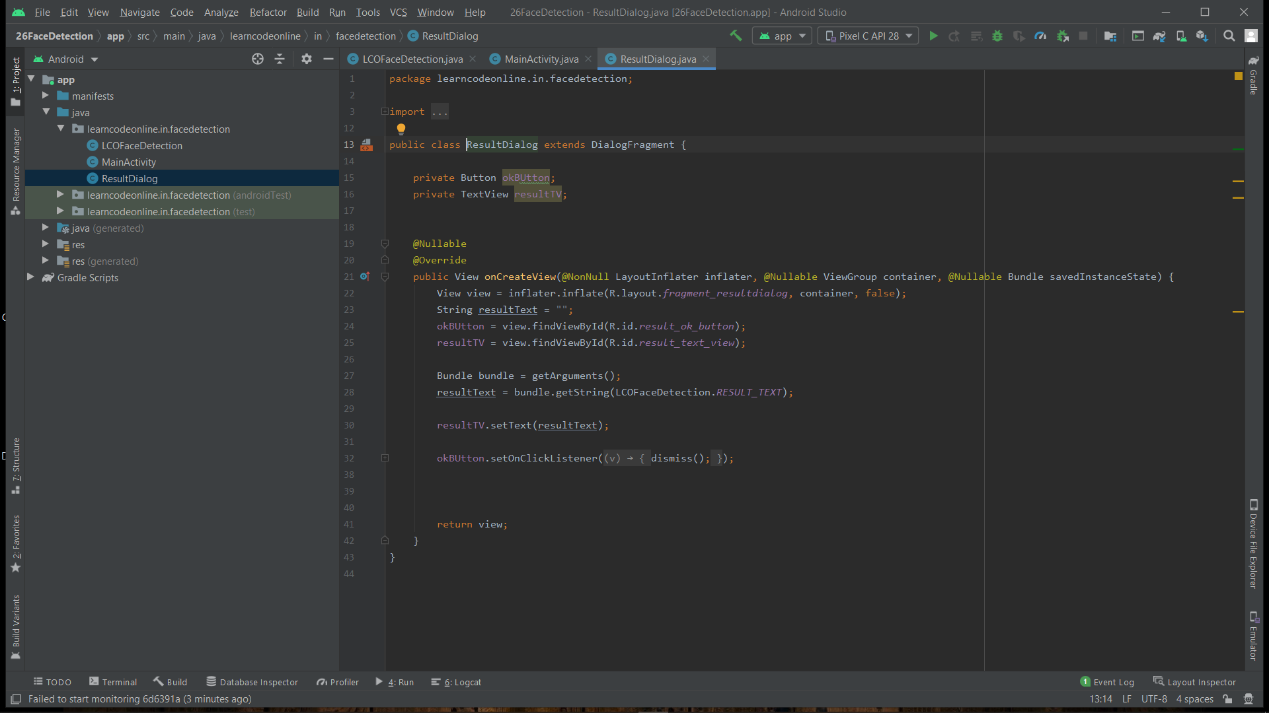

**SNAPSHOTS**

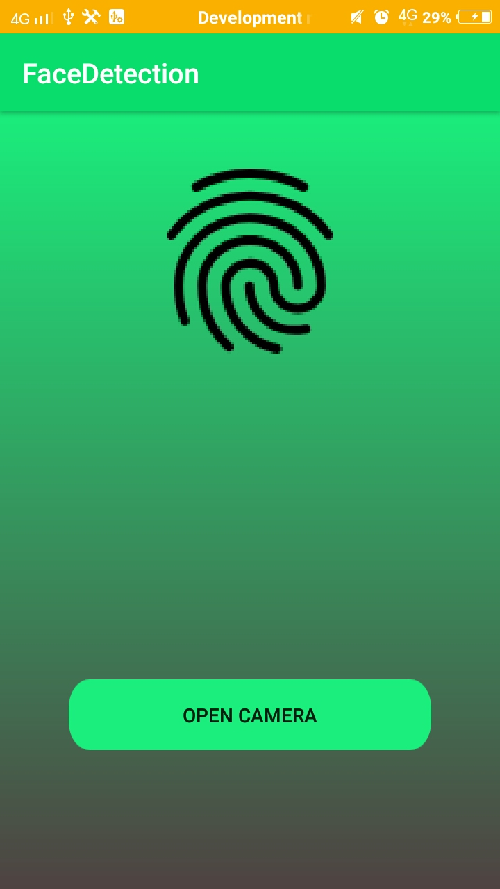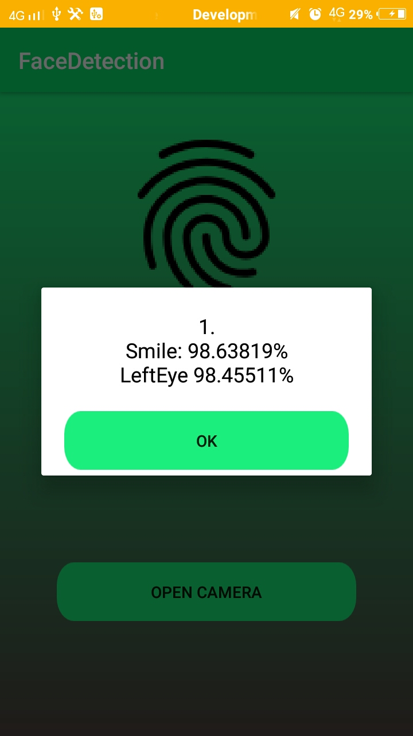

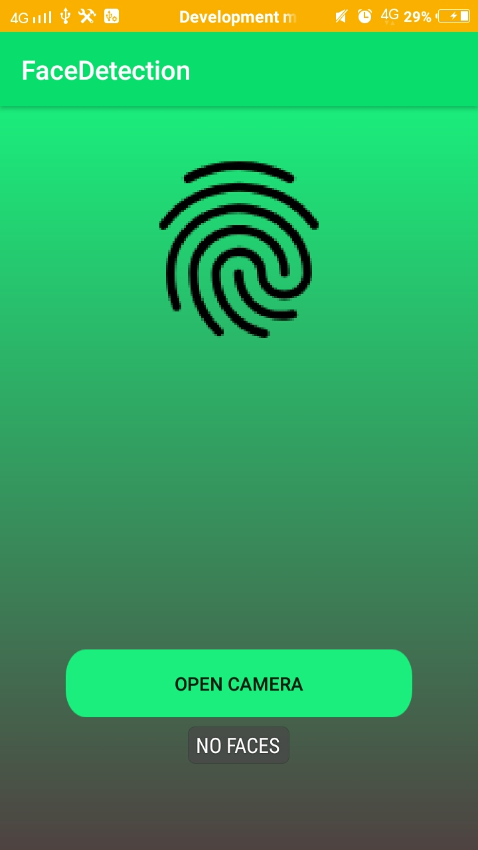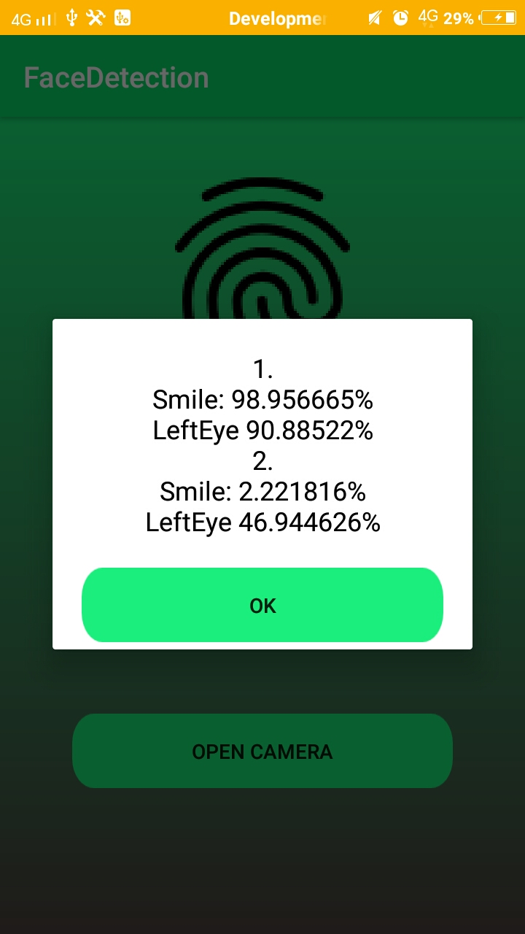

**CONCLUSION AND FUTURE SCOPE**

Today the cameras and microphones are very small, light-weight and have been effectively included into wearable systems. Audio and video recognition structures have the benefit that they use critical ways that humans use them for recognition. Face recognition systems used nowadays work thoroughly in restricted situations, even though they work properly with frontal pictures and steady illumination. We can say that almost all modern face recognition algorithms fail in exceptional situations wherein humans want to apply the concept of this generation. The subsequent generation of facial recognition structures need to apprehend humans in actual time and in situations far less restricted. The capability traits of this task are countless; the generation for facial recognition may be used withinside the future in nearly each industry, from education, medicine, marketing, global security, stadiums, authorities offices, transport, airports, borders etc. A practical example wherein this generation may want to revolutionize the sector and alternate the manner we engage now is to discover unwanted men and women on a list of suspects previously entered into the database or spotting companies' personnel or customers with which they engage. Another example could be in the healthcare domain for something as simple as patient check-in/check-out procedures, biometric analysis, to complex processes like diagnosis of diseases or conditions.

**REFERENCES**

1. [(PDF) Face Detection and Face Recognition in Android Mobile Applications](https://www.researchgate.net/publication/303880721_Face_Detection_and_Face_Recognition_in_Android_Mobile_Applications)
2. [Review: Face Detection and Recognition Techniques](http://ijcsit.com/docs/Volume%205/vol5issue03/ijcsit20140503319.pdf)
3. [Machine Learning](https://developer.android.com/ml)